**CHAPTER 5**

**SCREEN SHOTS**

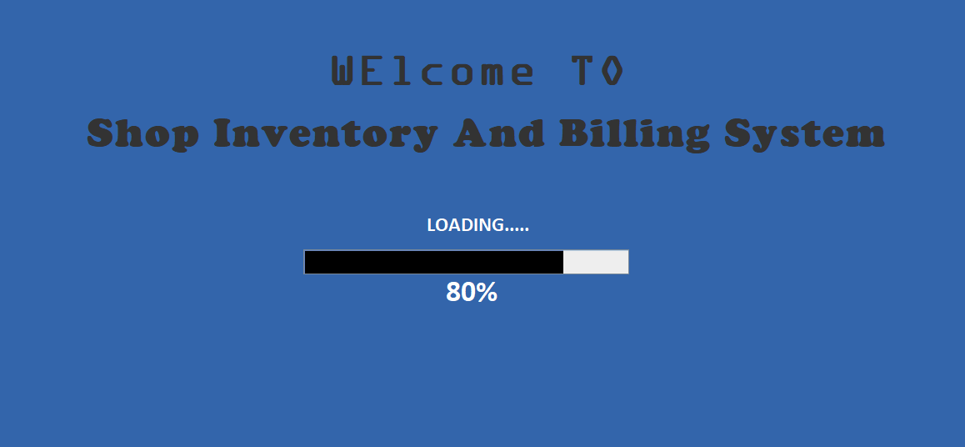

**Fig 5.1:** *Welcome page*

The Fig 5.1 is first interface in the Shop Inventory and Billing System. This frame contains the name of the System which says “Welcome to Shop Inventory and Billing System”. And it also contains a loading bar which counts from 0-100%. Once it finishes all the loading till 100% it automatically takes the user to Login interface.

The Fig 5.2 is alternatively referred to as a sign in, a login is a set of credentials used to gain access to an area that requires proper authorization. Logins are used to gain access to and control of System, as well as other services and devices. Today, logins consist of both a username and password. Also consist of “forget password?” feature in case the user forgets his password and also contains a feature “click here to create a new account” incase the user visits for the first time, which takes the user to next frame called “register form” where he can fill up all the asked details such as name, username, password and phone number and get access to the System.

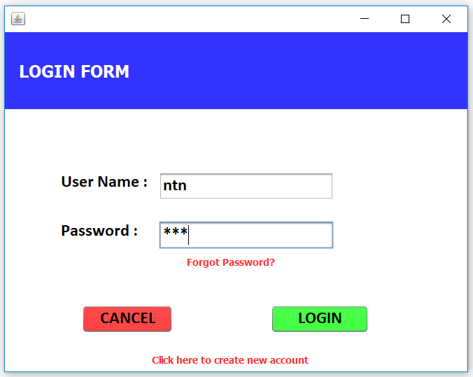

**Fig 5.2***: Login Screen*

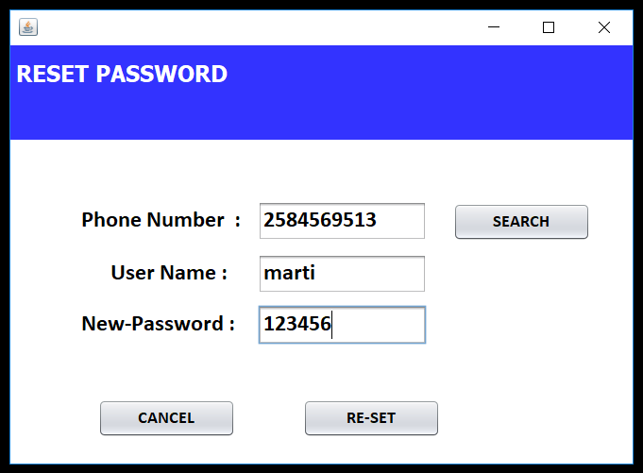

**Fig 5.3:** *Reset Password Screen*

Fig 5.3 shows the Reset Password form Where password can be reset in case the user forgets the password taking phone number as reference. The newly created Password can be used to Login again.

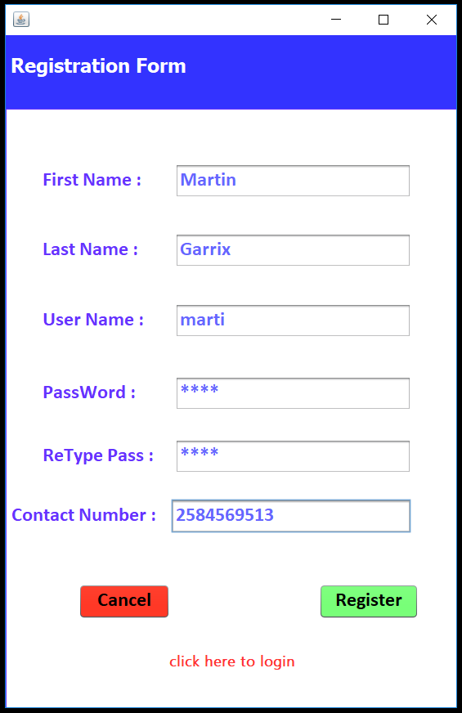

**Fig 5.4:** *Registration Screen*

Fig 5.4 shows the Registration form where user can create a personal account. Providing specified details like first name, last name, username, password, contact number etc. where contact number can be used for future reference to reset the password. Once the registration is done next frame will login frame where the registered username and password will give access to next frame.

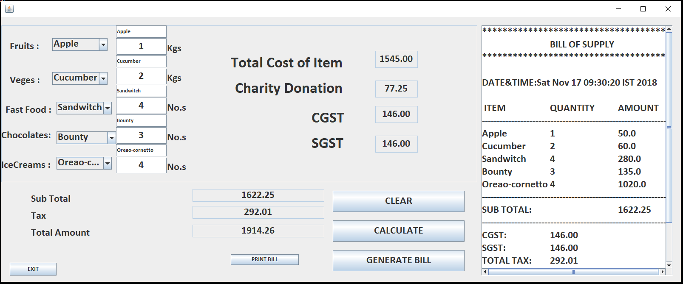

**Fig 5.5:** *Billing Screen*

Fig 5.5 Billing Screen is the interface for the shopkeeper for the billing process. User can select different categories like Fruits, Vegetables, Fast foods, Chocolates, Ice creams etc.

In every Categories there is different items for the user to select and provide quantity of the product. Different cost is given to different items. Where total cost can be calculated (without including tax). Charity donation cost is about 5% of total cost of item. Both CGST & SGST will cost 9% of total cost of item. And it also displays a subtotal calculation, total of tax and Total amount that Customer should pay. After calculation bill can be generated then a printout can be taken.

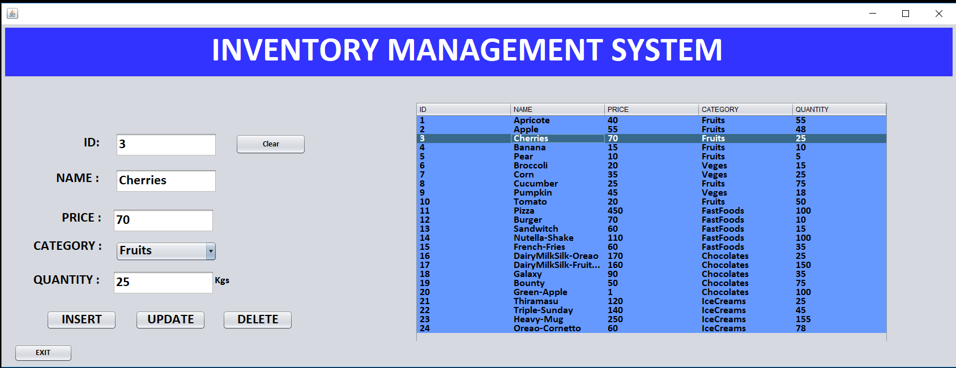

**Fig 5.6:** *Inventory management Screen*

Fig 5.6 shows an interface for the inventory management system. Where user can manipulate the items stored in the inventory. Interface contains a table which gives details about the stored items such as item id number, name of the product, price, category, quantity etc. here user can insert a new item, update the existing item and also delete the item. All the items will be instantly shown in the table while inserting, updating or deleting products.